**Day 5**  
Java Methods and Strings

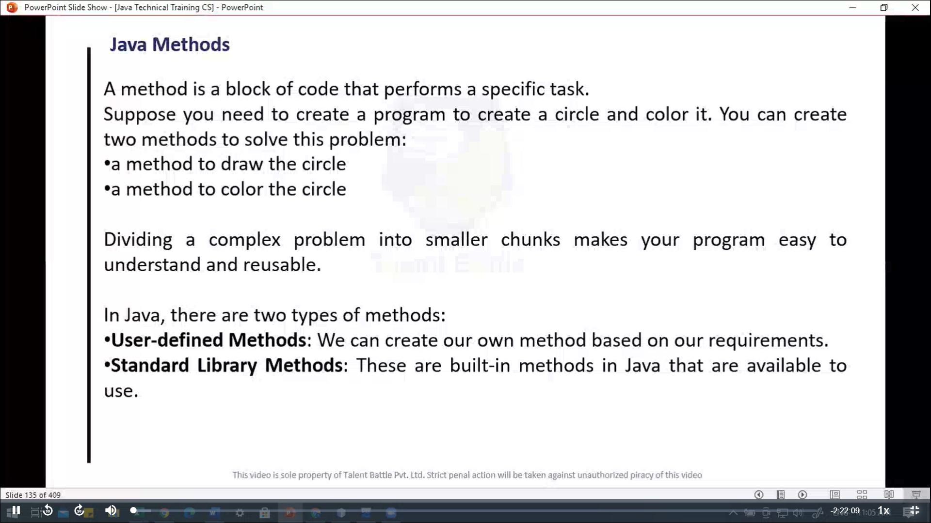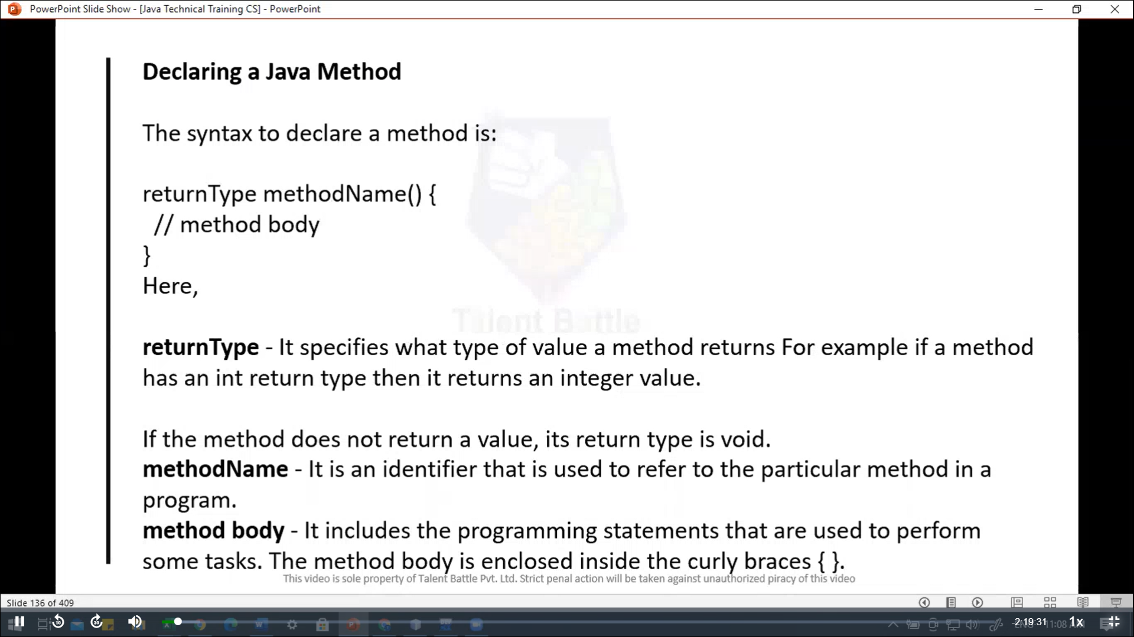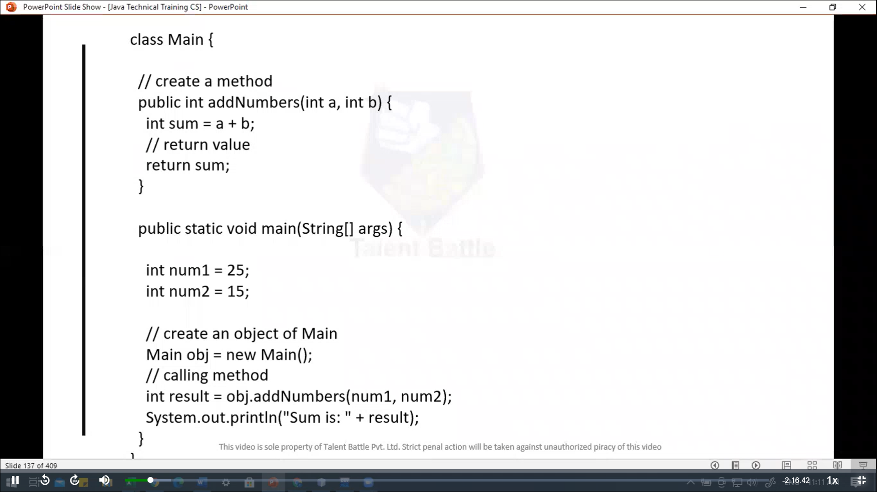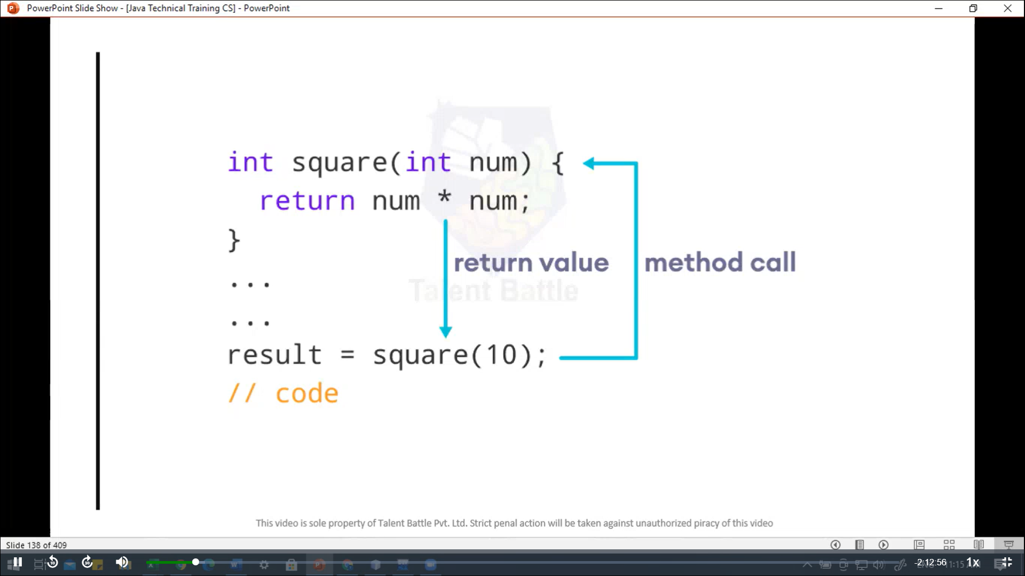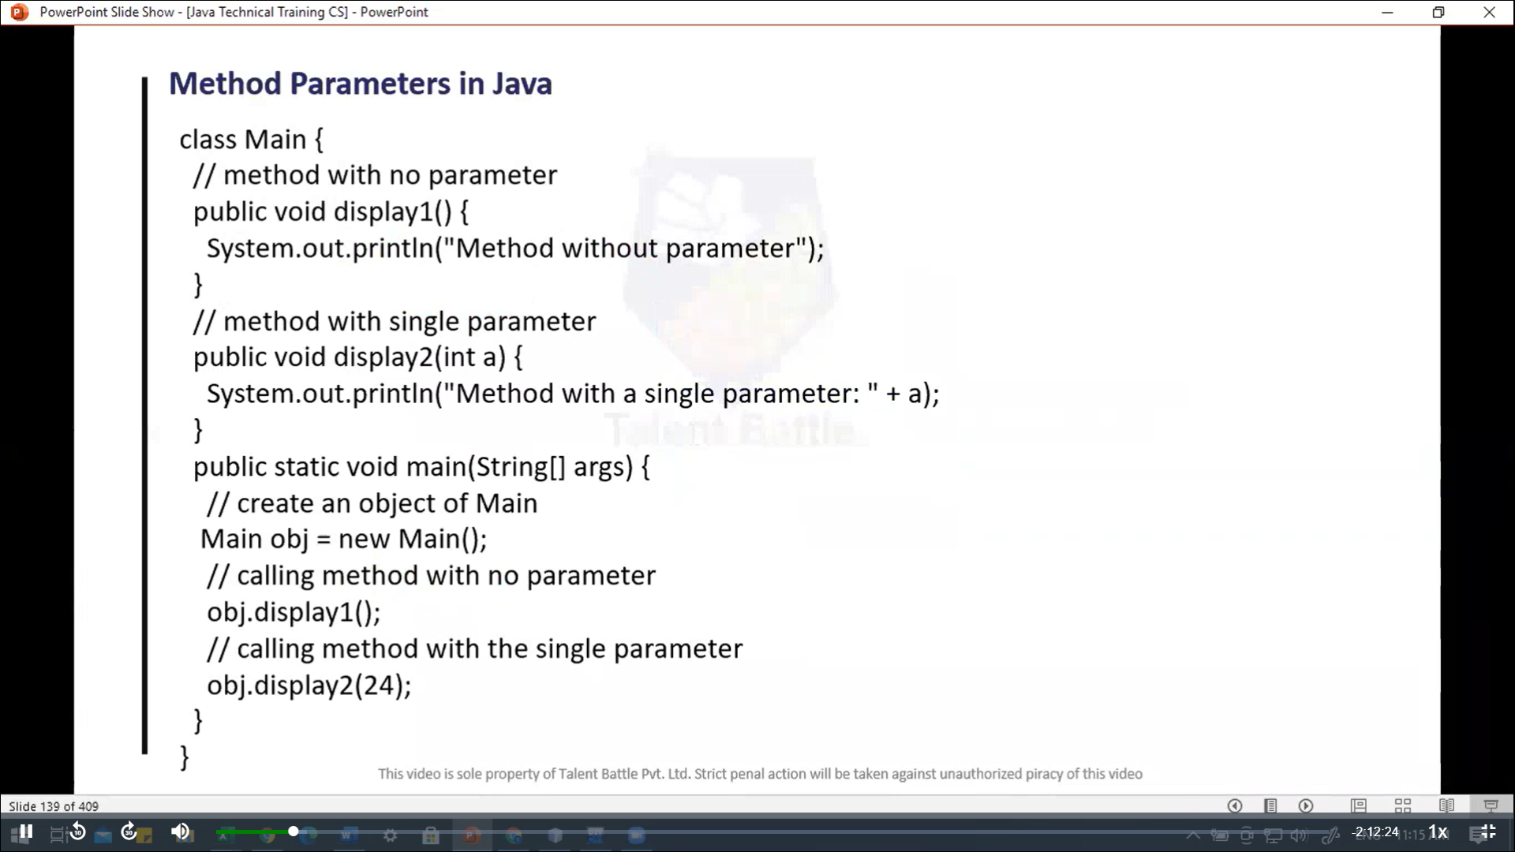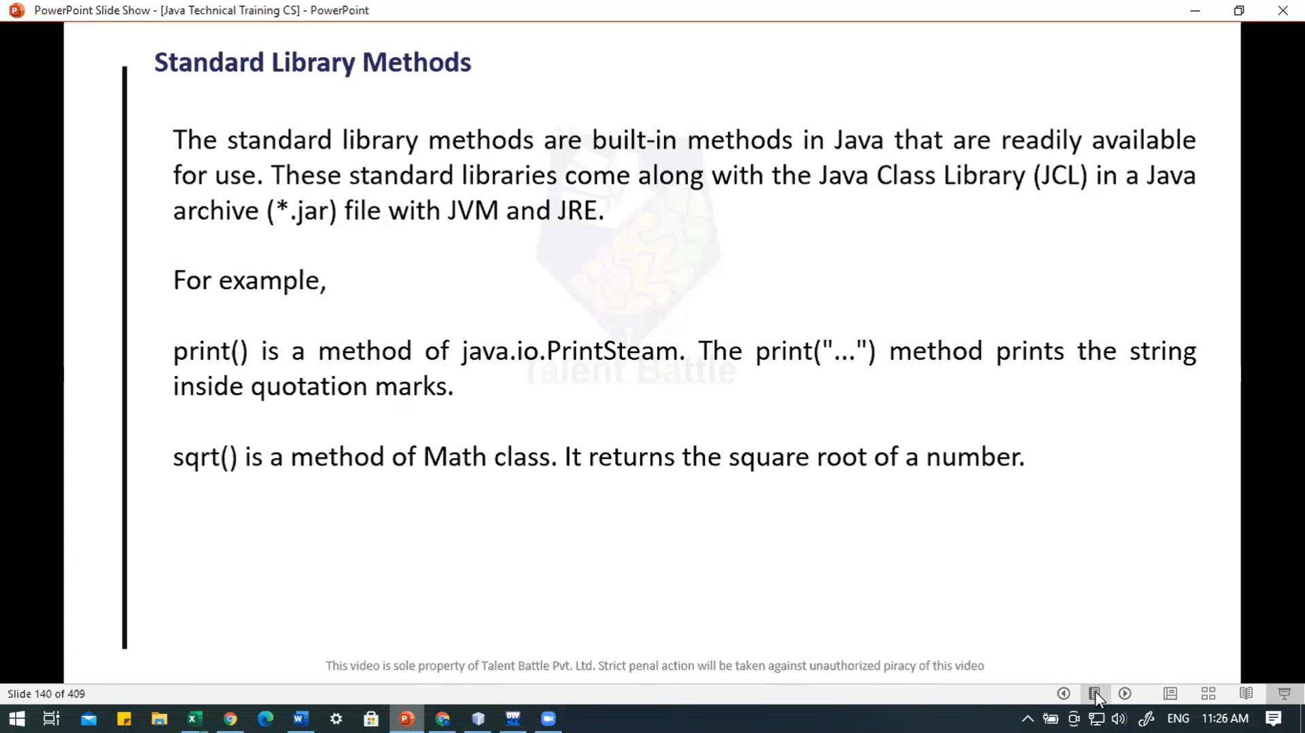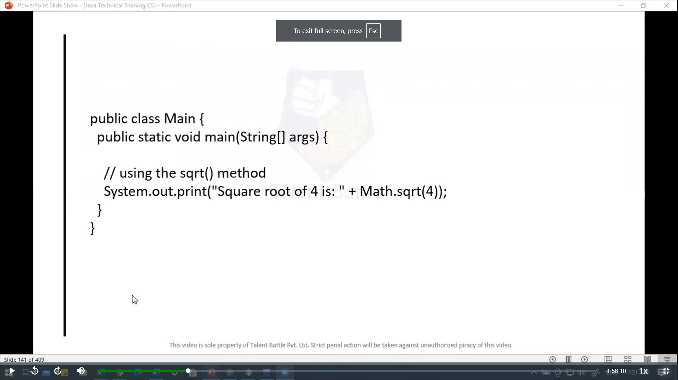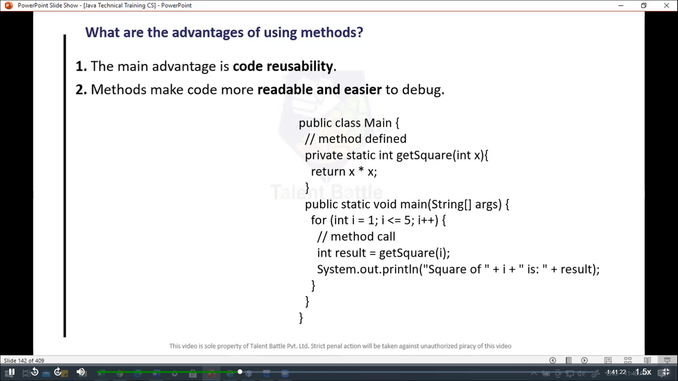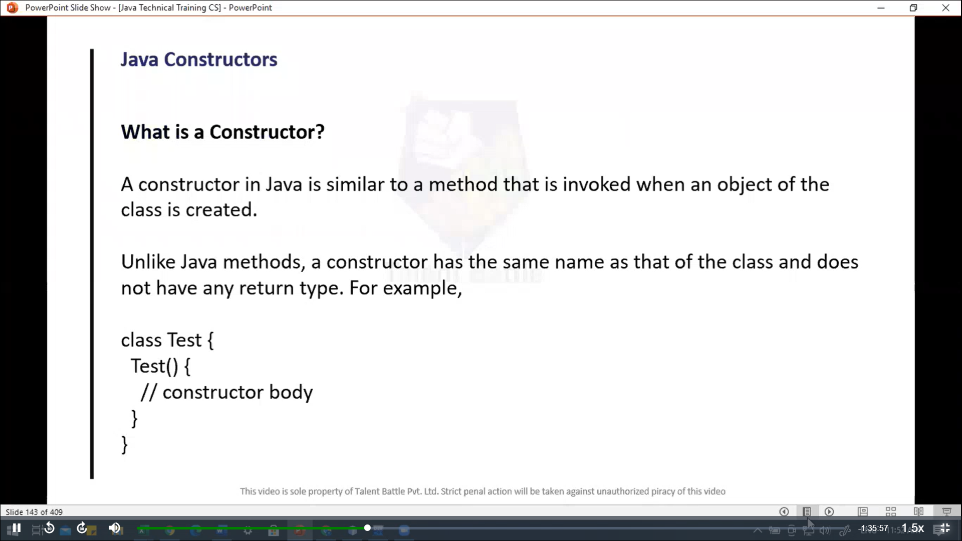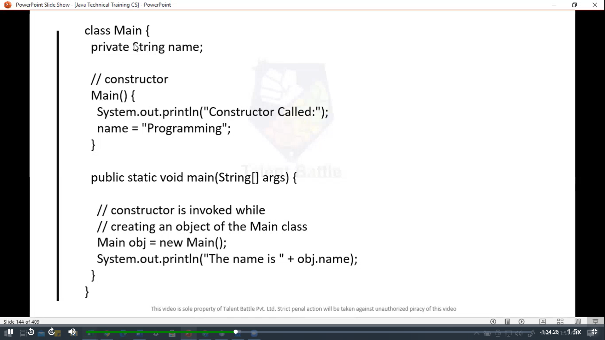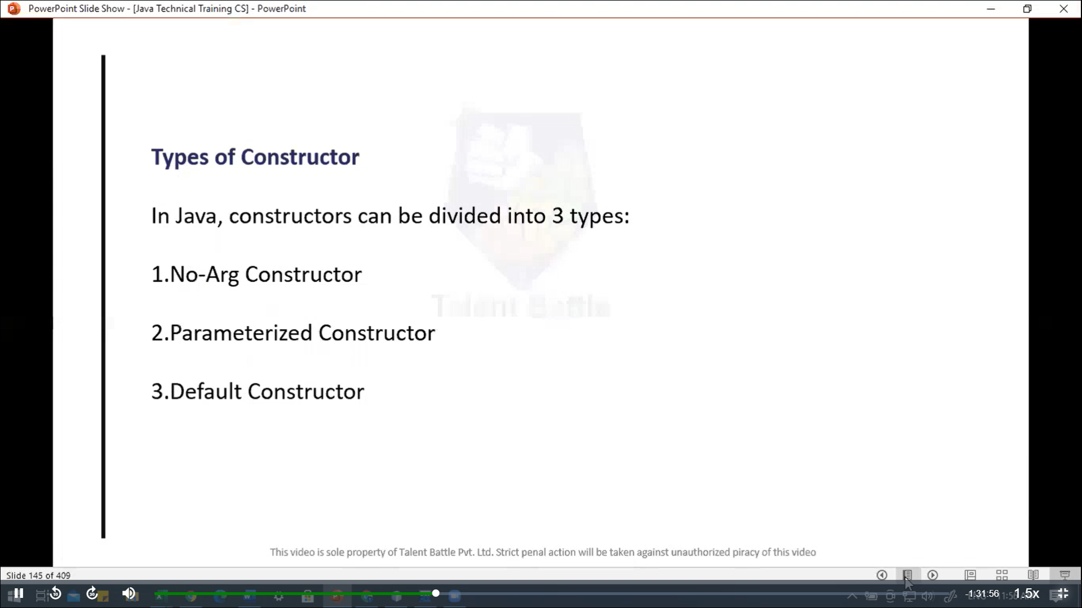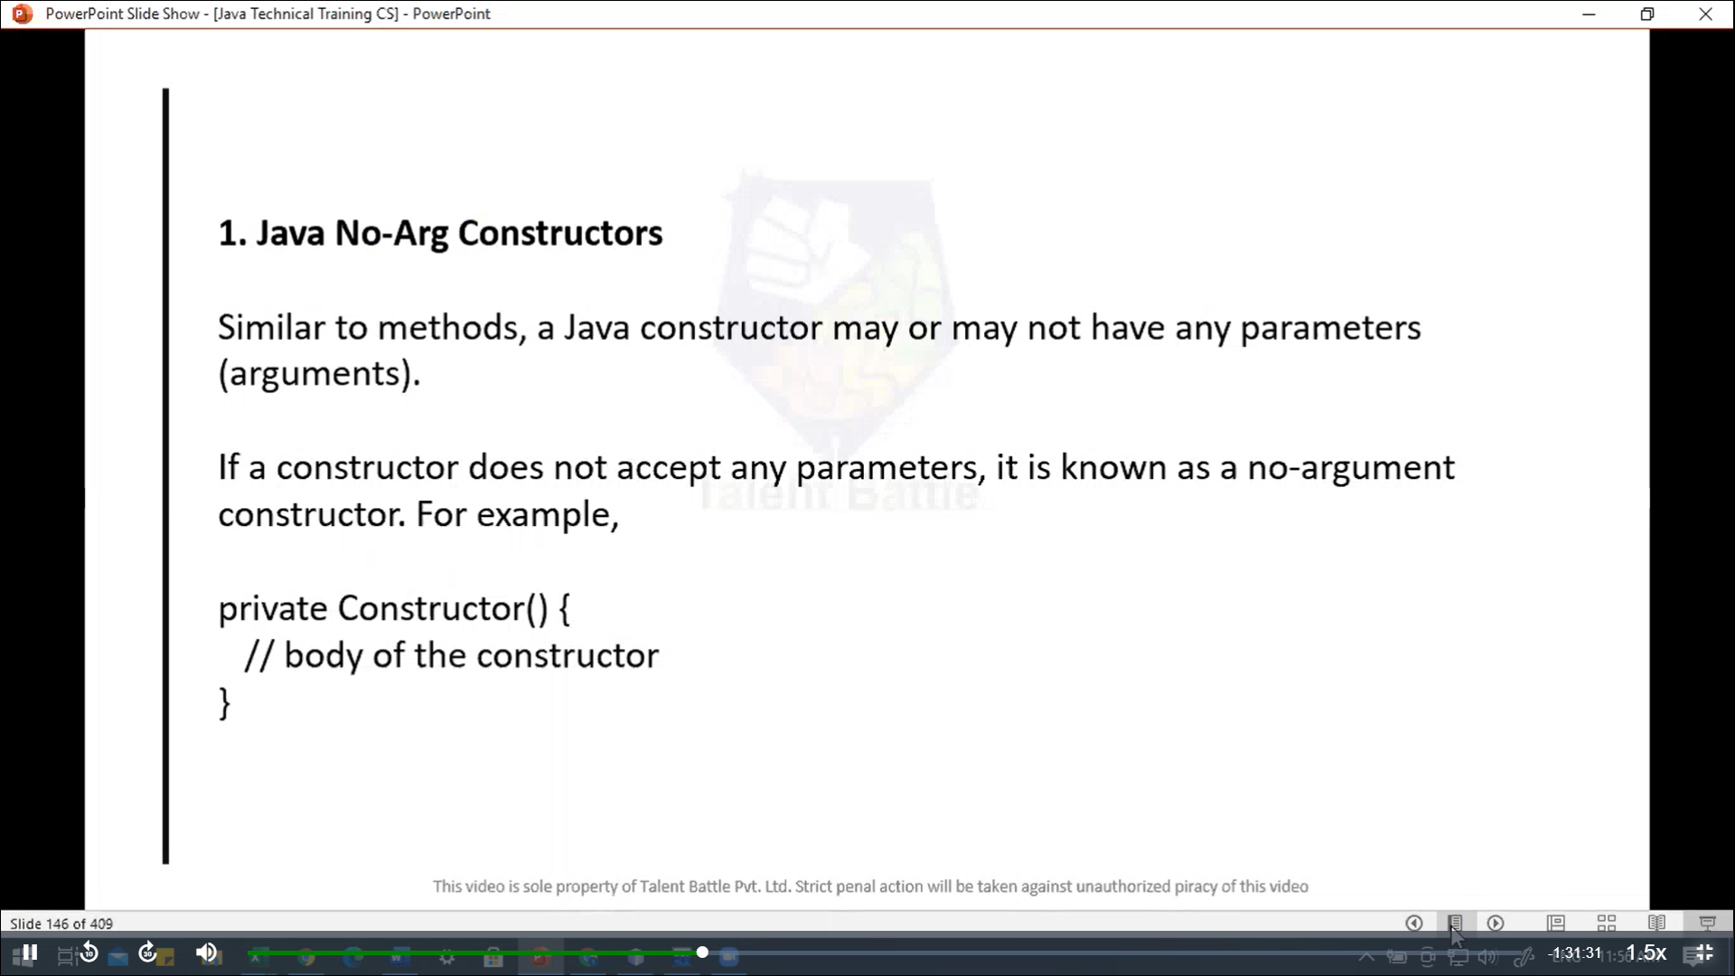 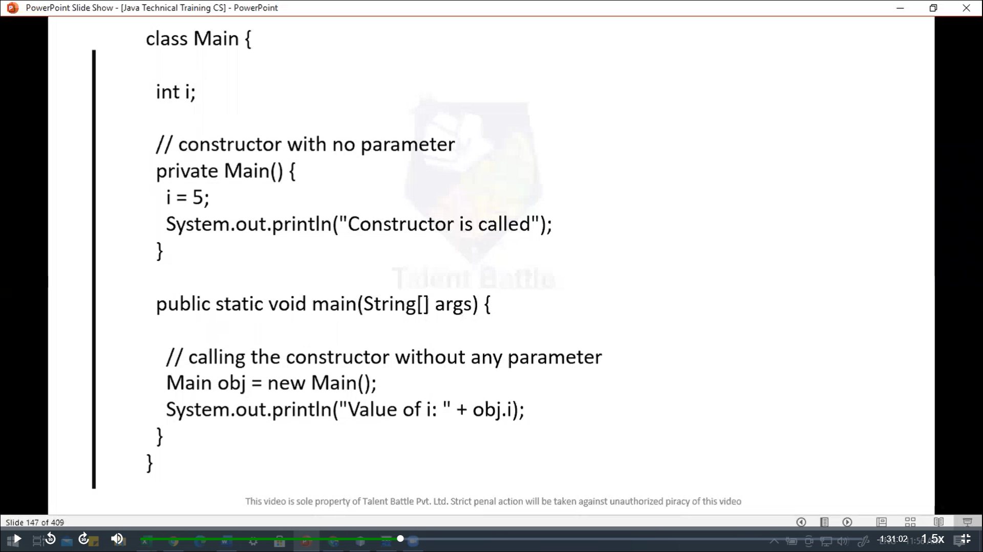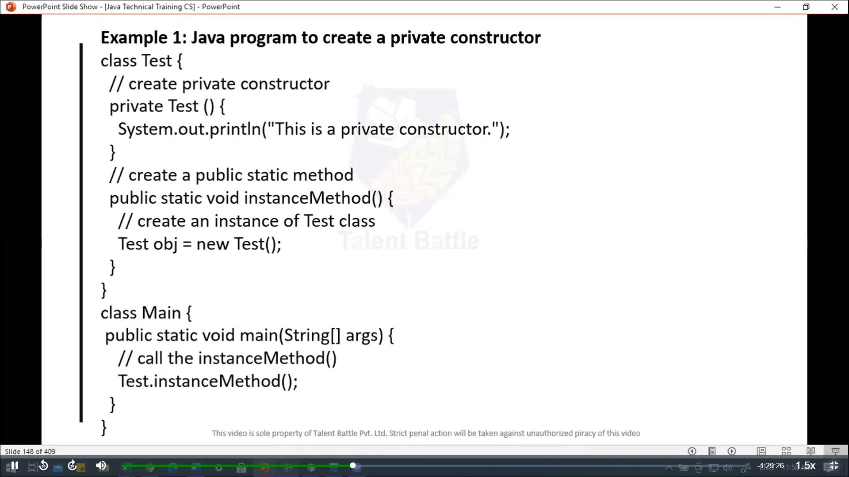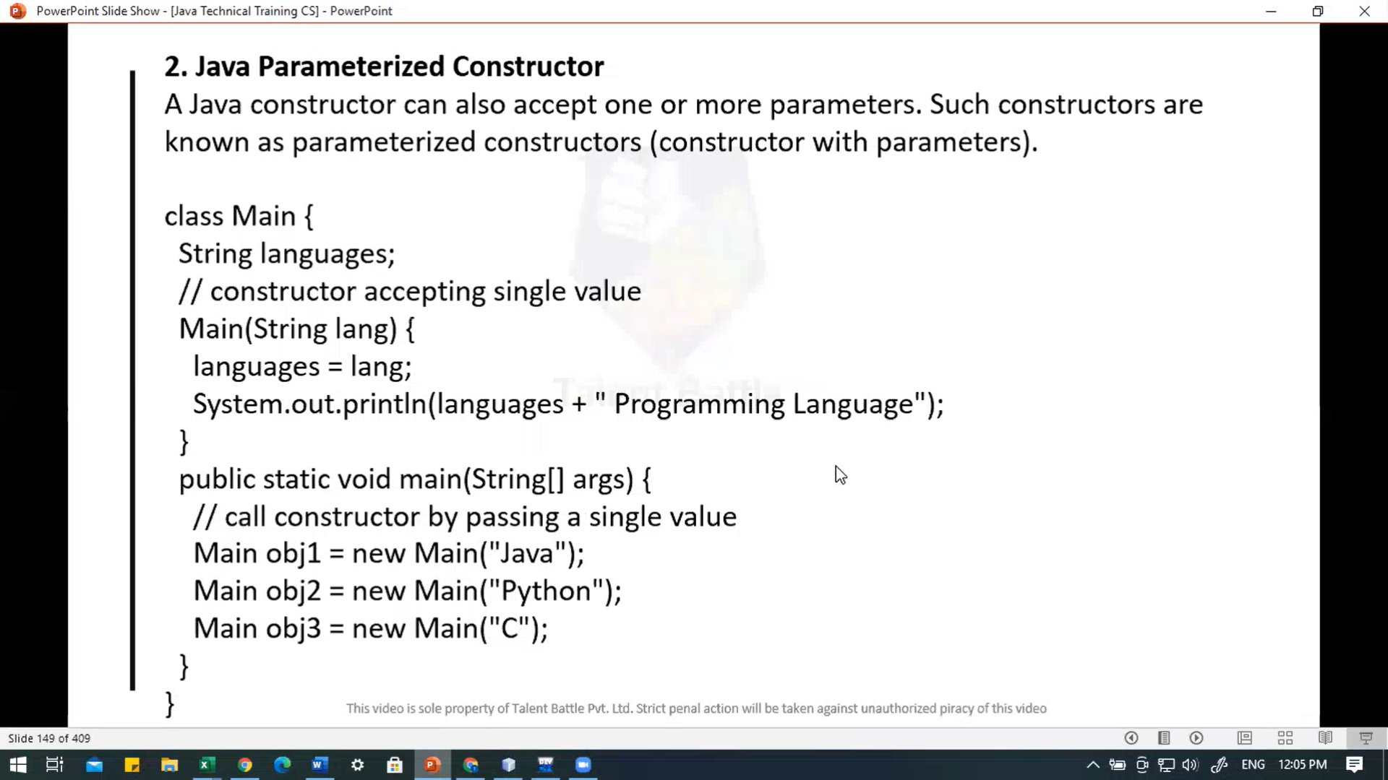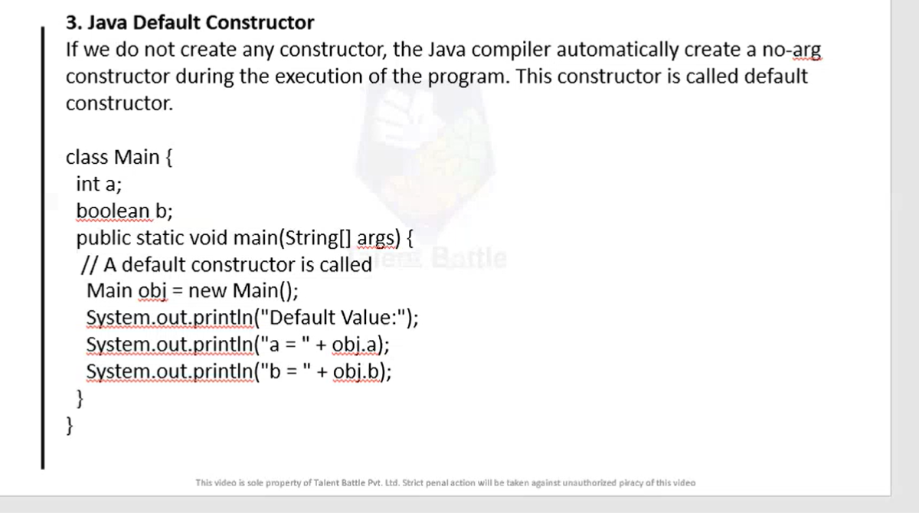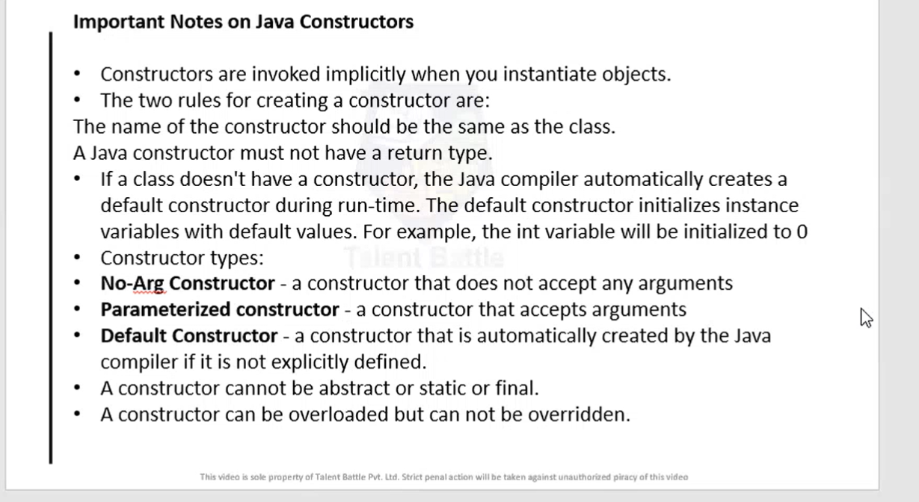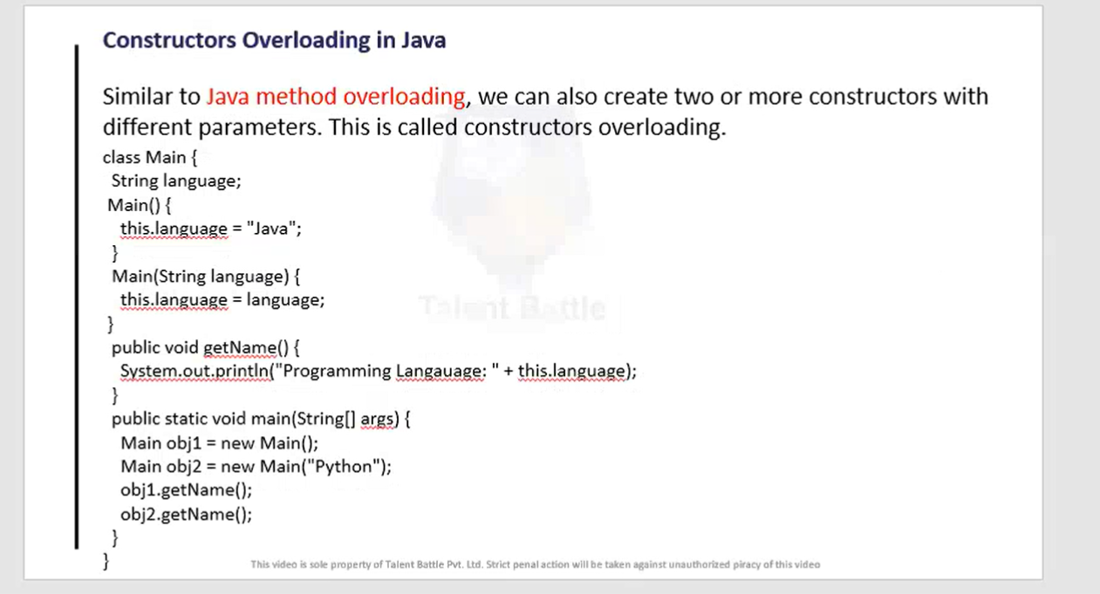

package Day5***;***

// Method

/*

public class Main {

  // create a method

  public int addNumbers(int a, int b){

    int sum = a + b;

    // return value

    return sum;

  }

  public static void main(String[] args){

    int num1 = 25;

    int num2 = 15;

    // create an object of Main

    Main obj = new Main();

    // calling method

    int result = obj.addNumbers(num1, num2);

    System.out.println("Sum is: " + result);

    // =========== output ================

    // PS C:\Users\hp\Desktop\TCS IT\Java> java Day5/Main.java

    // Sum is: 40

  }

}

 */

import java***.***lang***.***reflect***.***Method***;***

//================================================================

 // Method Parameters in java

/*

 public class Main {

  // method with no parameter

  public void display1(){

    System.out.println("Method without parameter");

  }

  // Method with single parameter

  public void display2(int a){

    System.out.println("Method with a single parameter: " + a);

  }

  public static void main(String[] args) {

    // create an object of Main

    Main obj = new Main();

    // calling method with no parameter

    obj.display1();

    // calling method with the single parameter

    obj.display2(24);

    // ======== output =============

    // PS C:\Users\hp\Desktop\TCS IT\Java> java Day5/Main.java

    // Method without parameter

    // Method with a single parameter: 24

  }

 }

   */

//==================================================================

// Standerd library method

/*

public class Main {

  public static void main(String[] args) {

    // using the sqrt() method

    System.out.println("Square root of 4 is: " + Math.sqrt(4));

  }

}

 */

 /*

// user input

import java.util.*;

public class Main {

  public static void main(String[] args) {

    // taking input from user

    System.out.println("Enter a number: ");

    double num;

    Scanner obj = new Scanner(System.in);

    num = obj.nextFloat();

    double result = Math.sqrt(num);

    System.out.println("Square Root of entered value is: " + result);

    // ============== output ===============

      // PS C:\Users\hp\Desktop\TCS IT\Java> java Day5/Main.java

      // Enter a number:

      // 25

      // Square Root of entered value is: 5.0

      // PS C:\Users\hp\Desktop\TCS IT\Java>

  }

}

 */

 //===========================================================

 /*

 // what are advantaes of using methods?

 // 1. Reusability of code

 // 2. Code organization

 // 3. Code readability

 public class Main {

  // method defined

  private static int getSquare(int x){

    return x * x;

  }

  public static void main(String[] args) {

    for (int i = 1; i <= 5; i++){

      // method call

      int result = getSquare(i);

      System.out.println("Square of " + i + " is: " + result);

    }

  }

 }

 // ============ output ================

  // PS C:\Users\hp\Desktop\TCS IT\Java> java Day5/Main.java

  // Square of 1 is: 1

  // Square of 2 is: 4

  // Square of 3 is: 9

  // Square of 4 is: 16

  // Square of 5 is: 25

 */

 //============================================================

 /*

 // Constructor

 public class Main {

  private String name;

  // constructor

  Main(){

    System.out.println("Constructor Called: ");

    name = "Programming";

  }

  public static void main(String[] args) {

    // constructor is invoked while

    // creating an object of the Main class

    Main obj = new Main();

    System.out.println("The name is " + obj.name);

  }

 }

 // =========== output ===============

  // PS C:\Users\hp\Desktop\TCS IT\Java> java Day5/Main.java

  // Constructor Called:

  // The name is Programming

 */

 //=====================================================

 /*

 // No argument constructor

 public class Main {

  int i;

  // constructor with no parameter

  private Main(){

    i = 5;

    System.out.println("Constructor is called ");

  }

  public static void main(String[] args) {

    // calling the constructor without any parameter

    Main obj = new Main();

    System.out.println("Value of i: " + obj.i);

  }

 }

 // =============== output ======================

  // PS C:\Users\hp\Desktop\TCS IT\Java> java Day5/Main.java

  // Constructor is called

  // Value of i: 5

 */

//=========================================================

/*

// Example 1: Java program to create a private constructor

class Test{

  // create private constructor

  private Test(){

    System.out.println("Private constructor called");

  }

  // create a public static method

  public static void instanceMethod(){

    // create an instance of Test class

    Test obj = new Test();

  }

}

public class Main {

  public static void main(String[] args) {

    // call the instanceMethod()

    Test.instanceMethod();

  }

}

// ============== output ================

// PS C:\Users\hp\Desktop\TCS IT\Java> javac .\Day5\Main.java

// PS C:\Users\hp\Desktop\TCS IT\Java> java Day5.Main

// Private constructor called

// PS C:\Users\hp\Desktop\TCS IT\Java>

*/

//====================================================

/*

// 2. Java parameterized constructor

// A java constructor can also accept one or more parameters. Such constructors are known as parameterized constructors (constructor with parameters)

public class Main {

  String languages;

  // constructor accepting single value

  Main(String lang){

    languages = lang;

    System.out.println(languages + " Programming Languages");

  }

  public static void main(String[] args) {

    // call constructor by passing a single value

    Main obj1 = new Main("Java");

    Main obj2 = new Main("Python");

    Main obj3 = new Main("C++");

  }

}

// =========== output ================

// PS C:\Users\hp\Desktop\TCS IT\Java> javac .\Day5\Main.java

// PS C:\Users\hp\Desktop\TCS IT\Java> java Day5/Main.java

// Java Programming Languages

// Python Programming Languages

// C++ Programming Languages

// PS C:\Users\hp\Desktop\TCS IT\Java>

 */

 //======================================================

/*

 // 3. Java Default constructor

 // If we do not create any constructor, the java compiler automatically create a no-argument constructor during the execution of the program. This constructor is called default constructor.

 public class Main {

  int a;

  boolean b;

  public static void main(String[] args) {

    // a default constructor is called

    Main obj = new Main();

    System.out.println("Default value: ");

    System.out.println("a = " + obj.a);

    System.out.println("b = " + obj.b);

  }

 }

 // ============================= output =============================

  // PS C:\Users\hp\Desktop\TCS IT\Java> java Day5/Main.java

  // Default value:

  // a = 0

  // b = false

  // PS C:\Users\hp\Desktop\TCS IT\Java>

 */

 //===============================================================

 // Constructors Overloading in java

 // Similar to java method overloading, we can also create two or more constructors with different paramenters. This is called constructors overloading.

 public class Main {

  String language***;***

*Main*(){

    this***.***language = "Java"***;***

  }

*Main*(String ***language***){

    this***.***language = language***;***

  }

  public void *getName*(){

    System***.***out***.****println*("Programming Language: " + this***.***language)***;***

  }

  public static void *main*(String[] ***args***) {

    Main obj1 = **new** *Main*()***;***

    Main obj2 = **new** *Main*("Python")***;***

    obj1***.****getName*()***;***

    obj2***.****getName*()***;***

  }

 }

 // =============== output ======================

//  PS C:\Users\hp\Desktop\TCS IT\Java> java Day5/Main.java

//  Programming Language: Java

//  Programming Language: Python

//  PS C:\Users\hp\Desktop\TCS IT\Java>

**Java Strings**

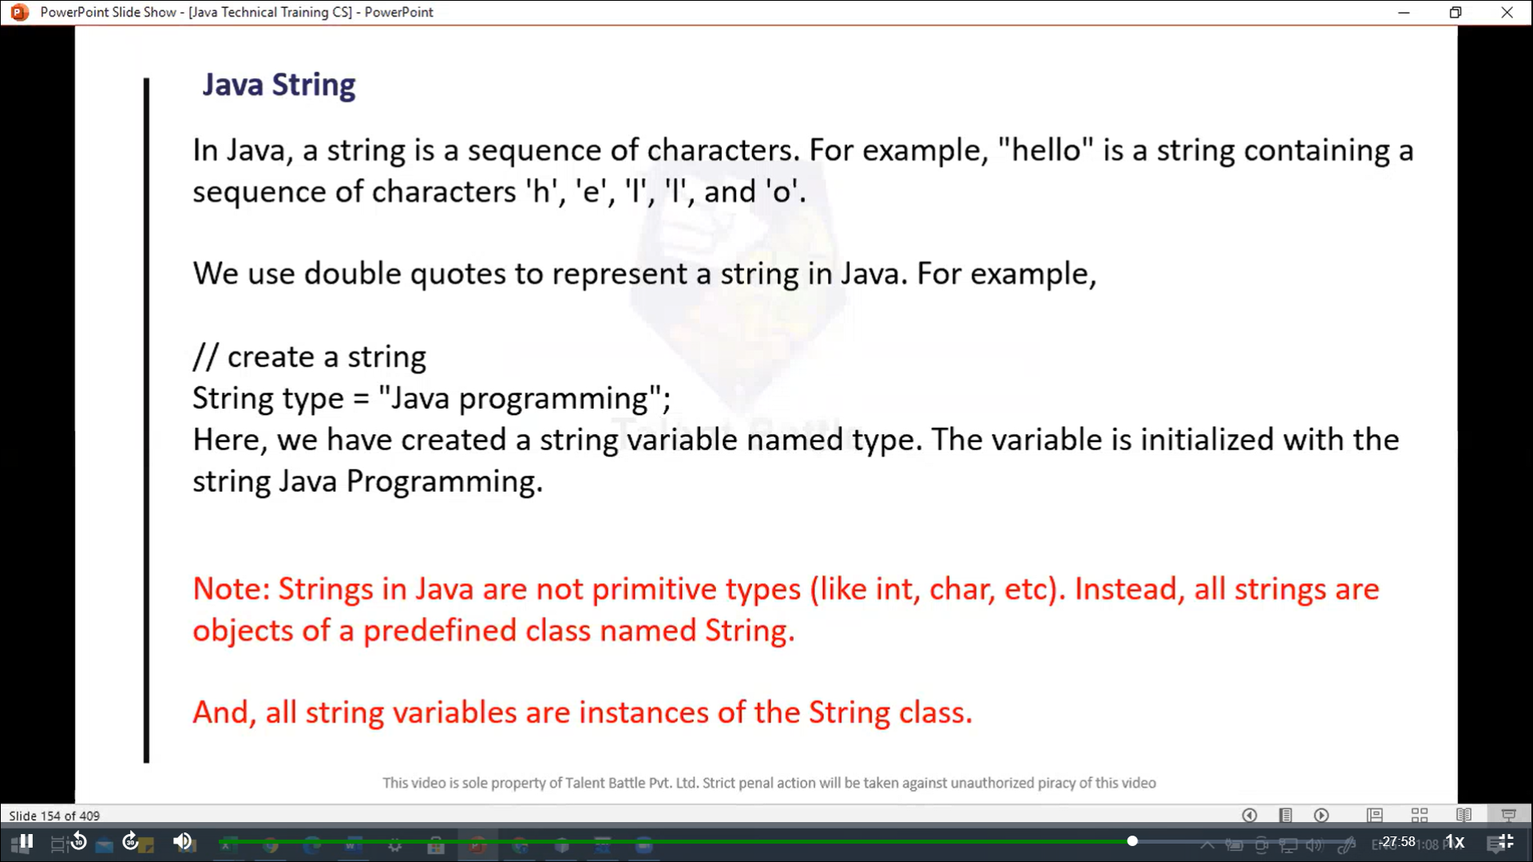

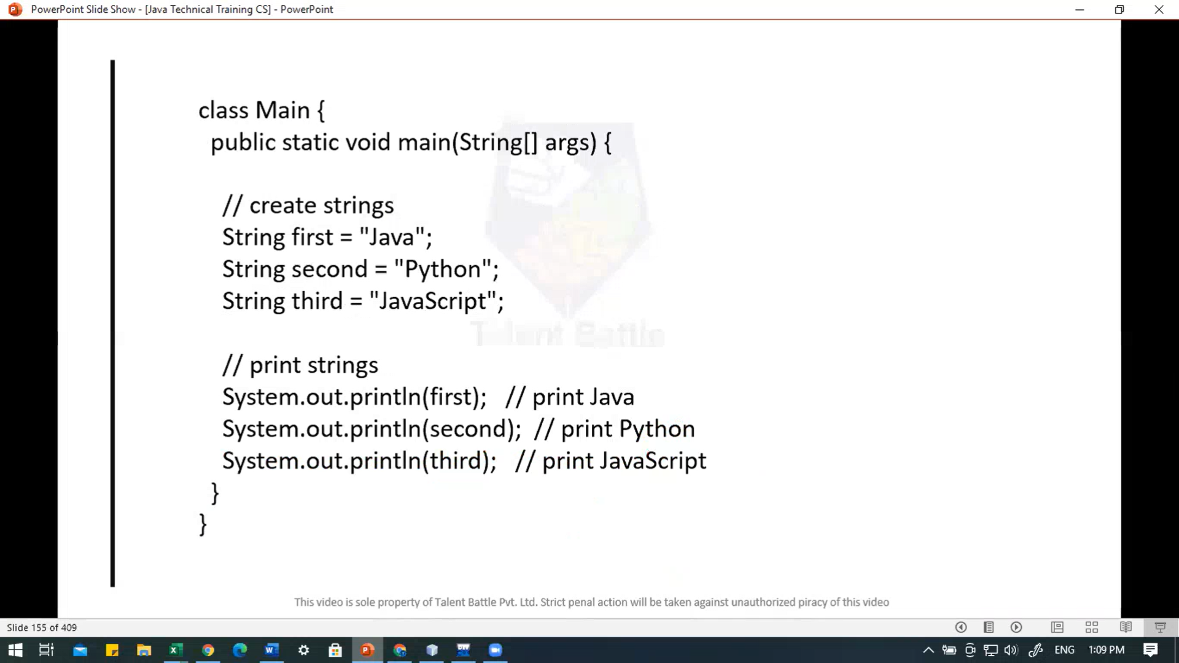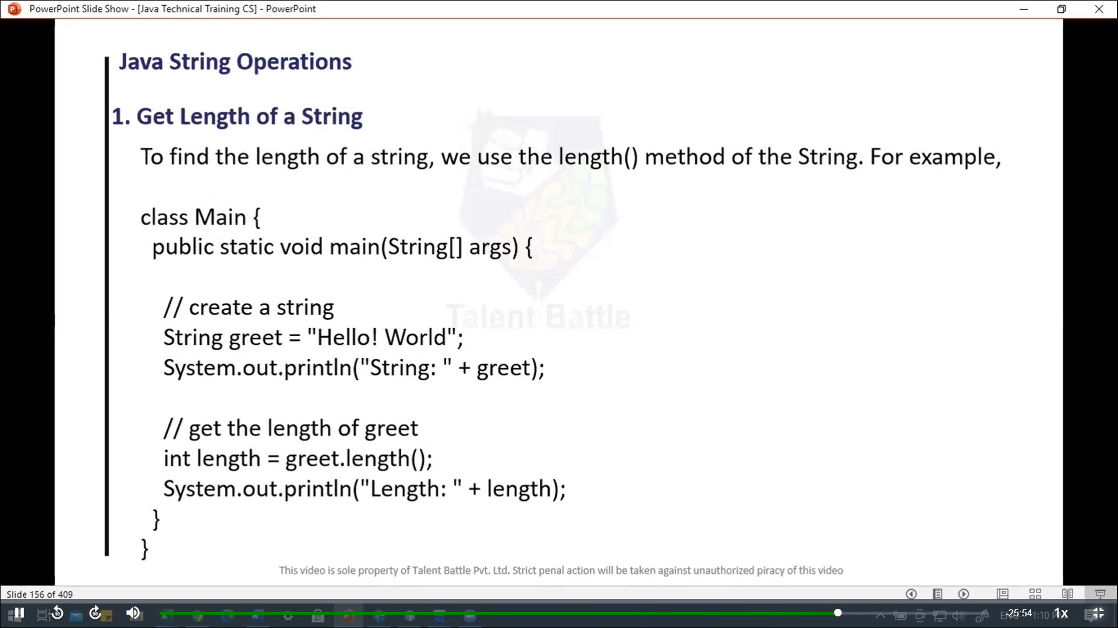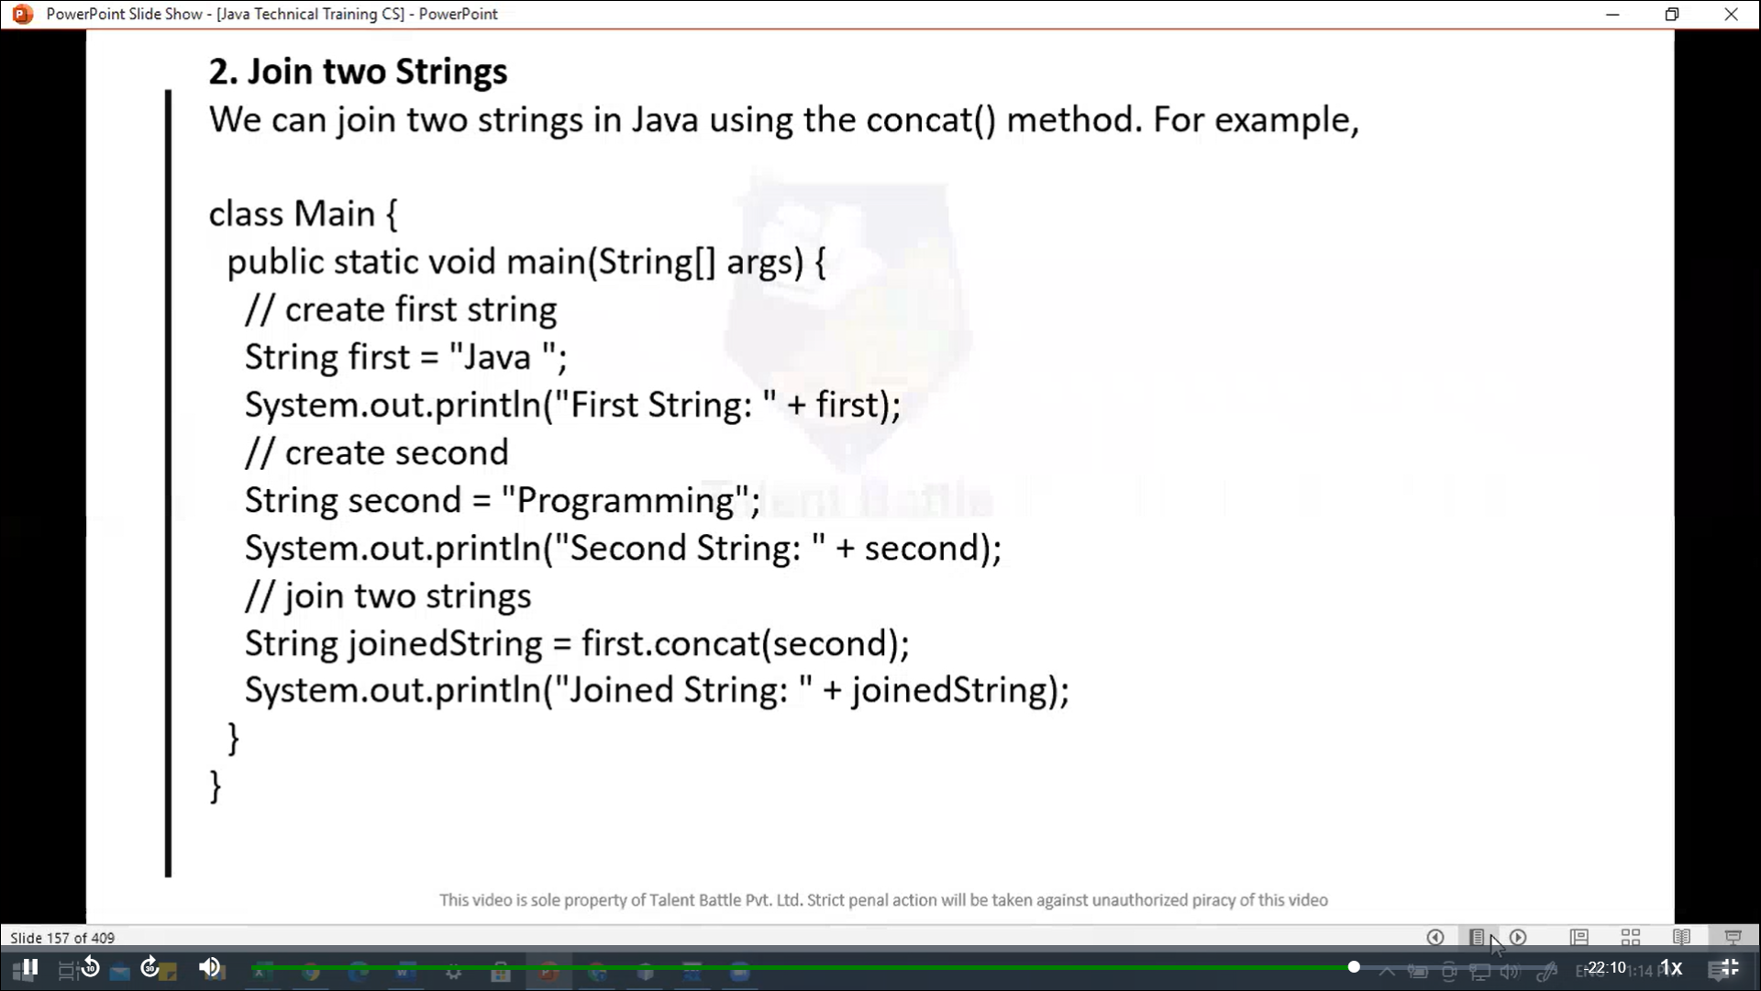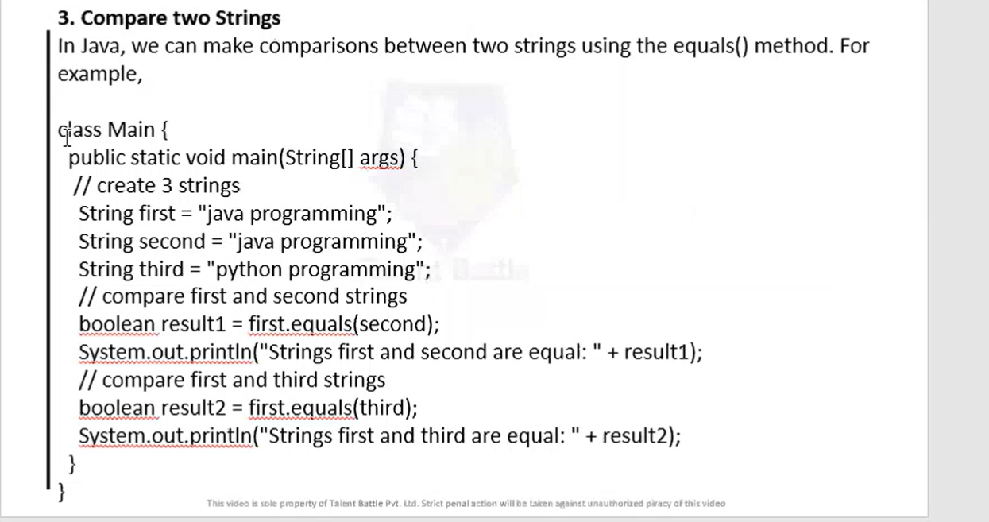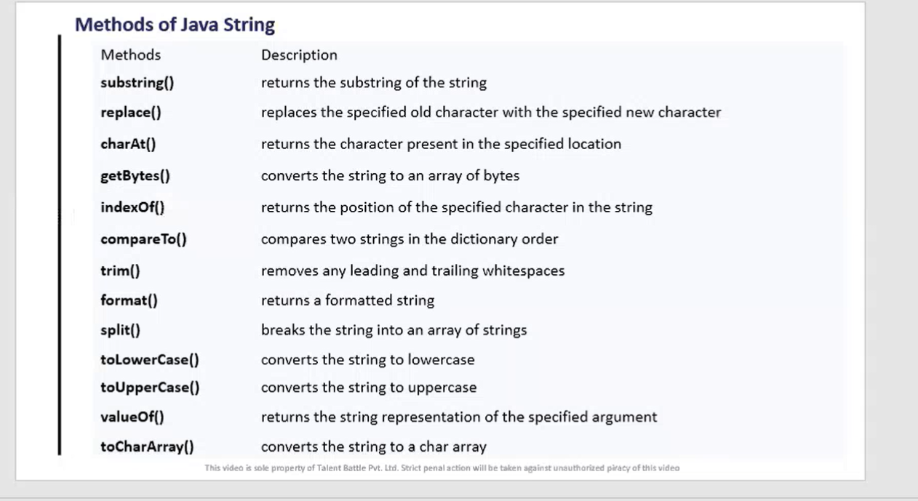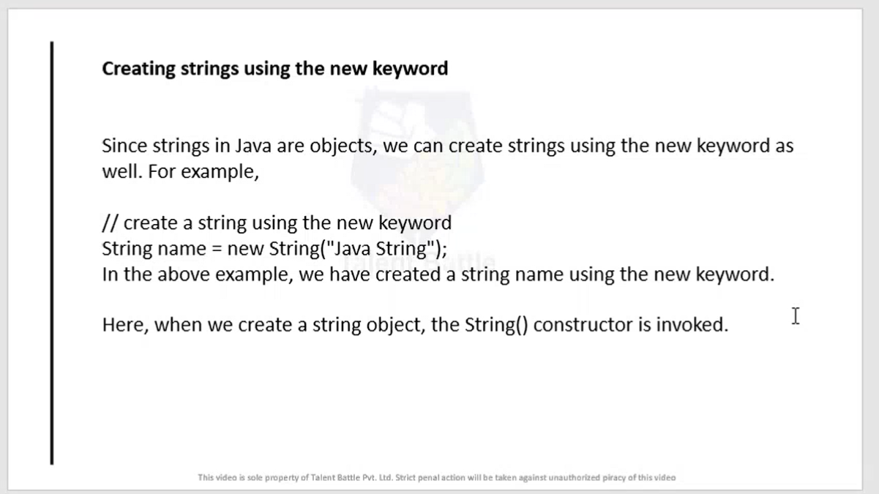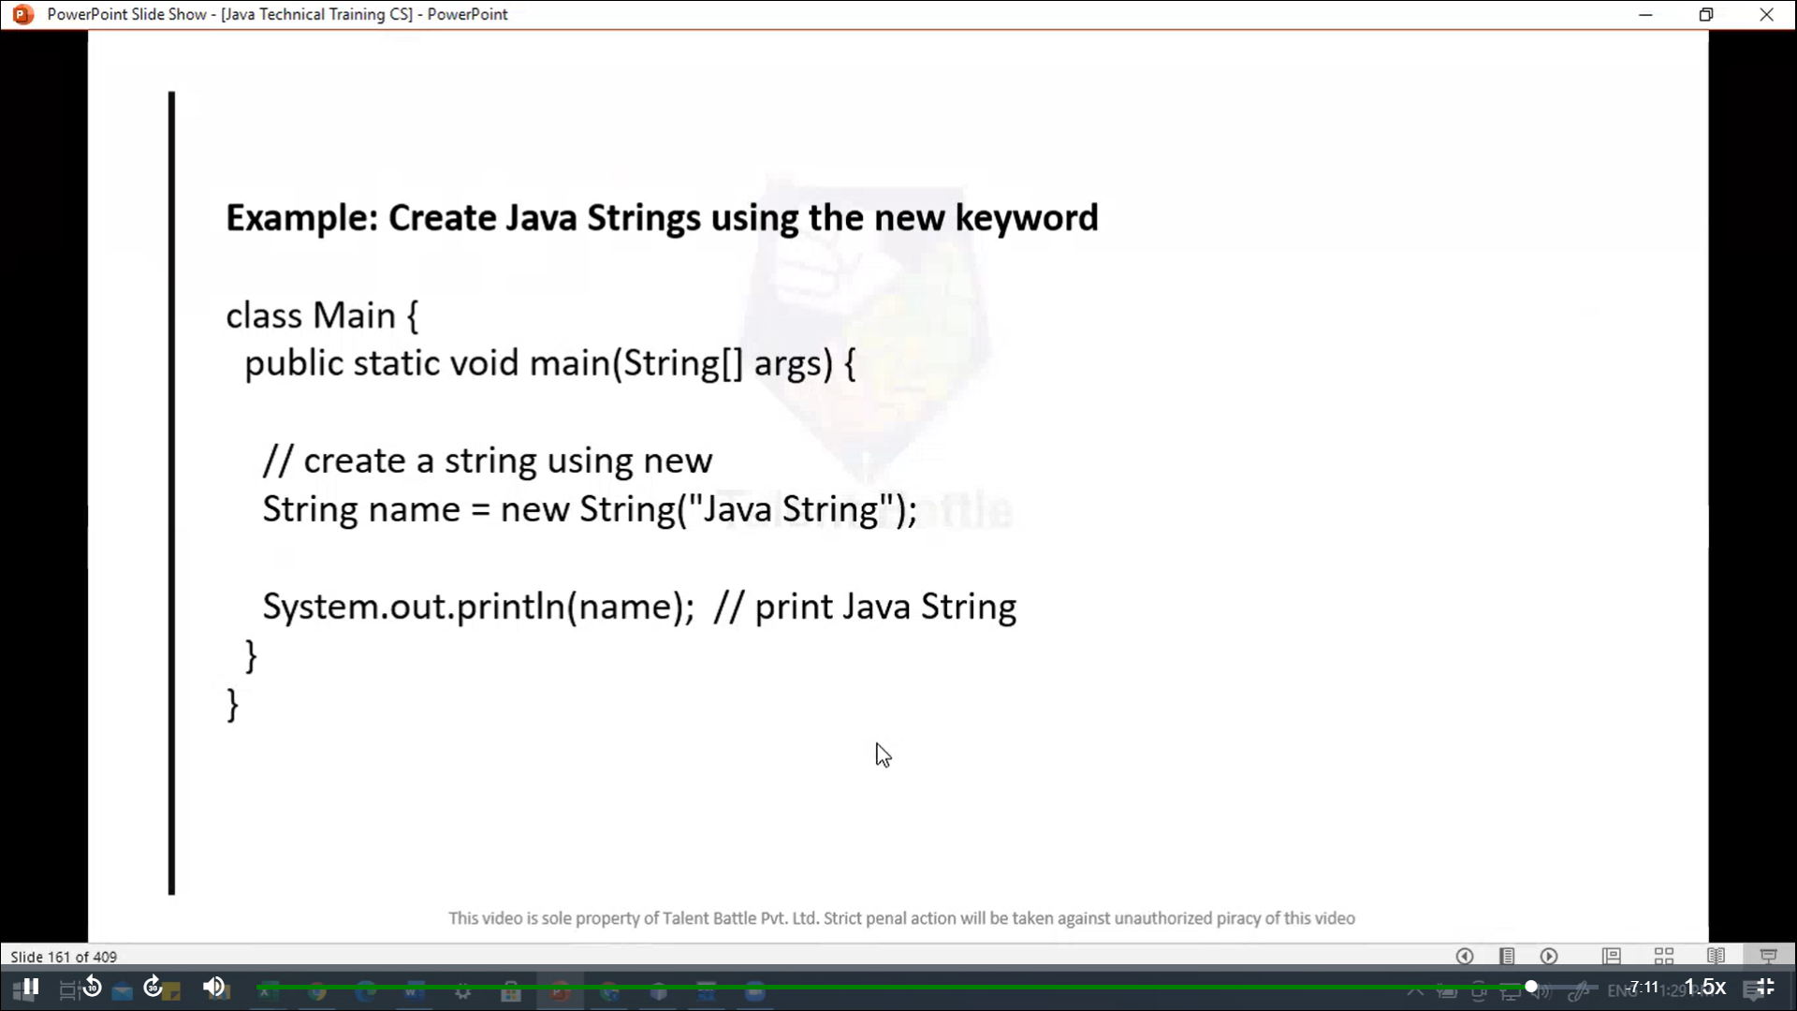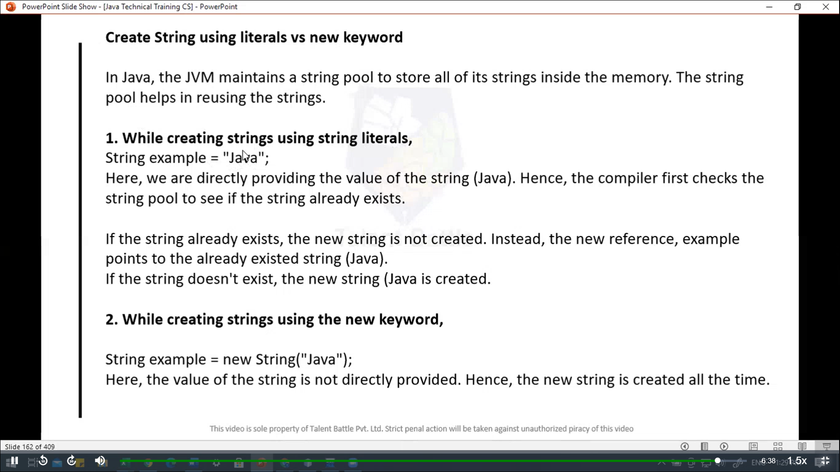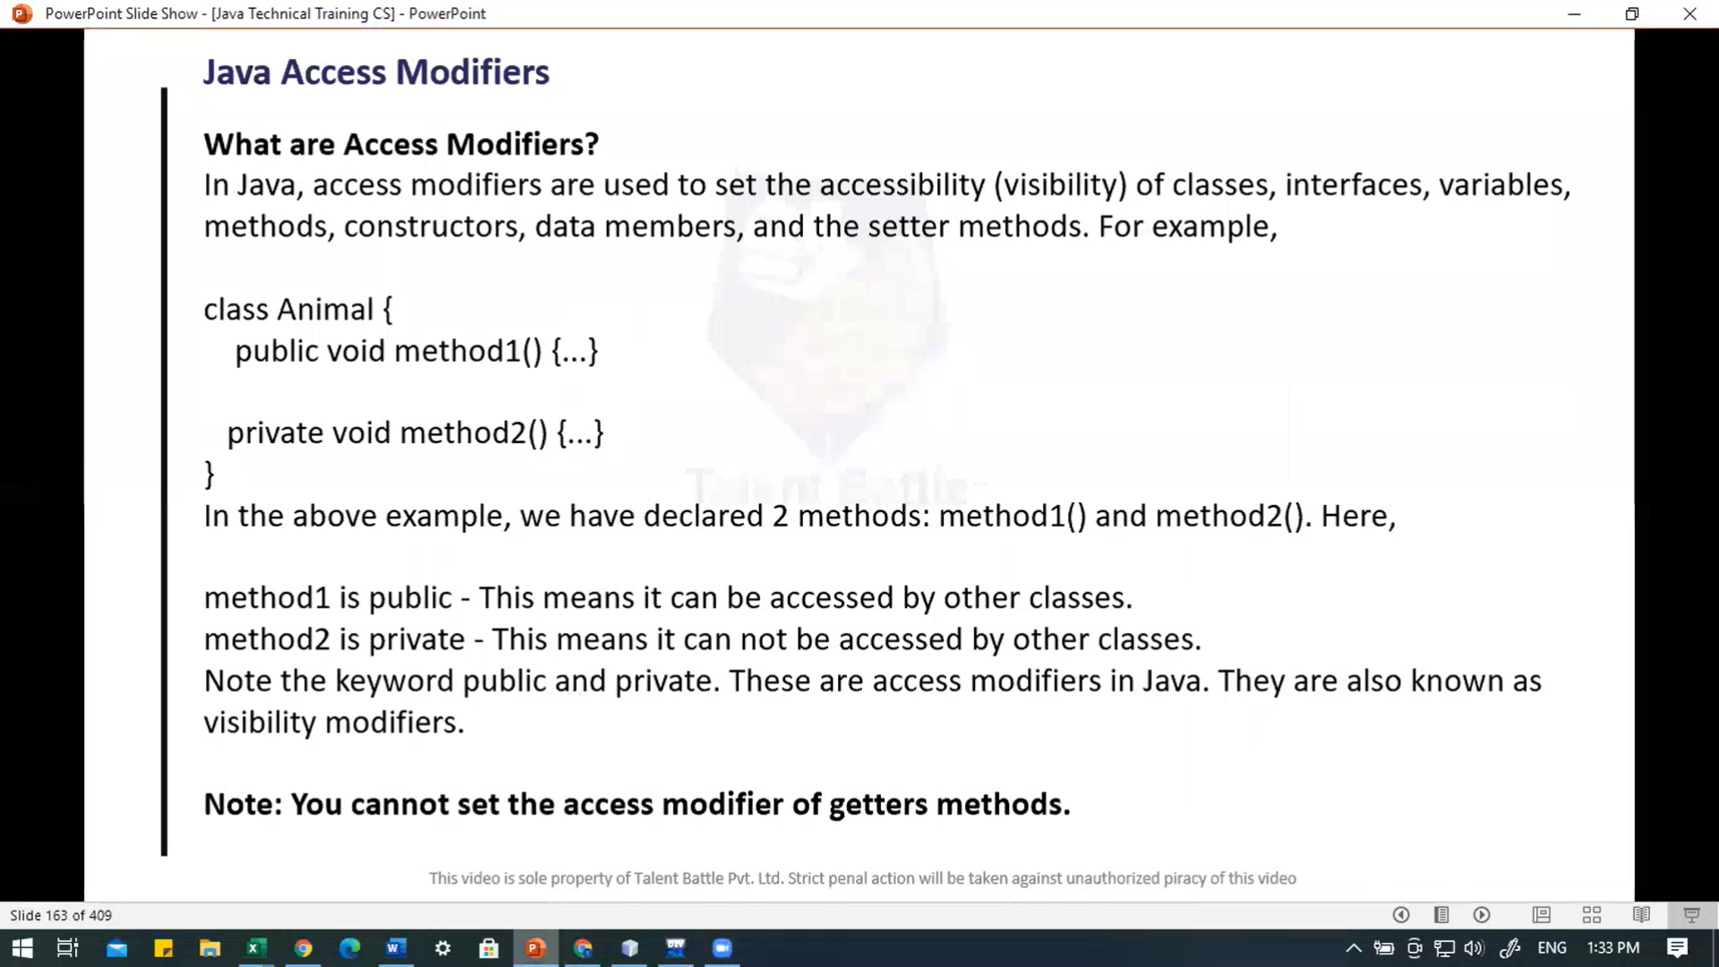

package Day5***;***

// java String

/*public class java_String {

  public static void main(String[] args) {

    // create strings

    String first = "java";

    String second = "Python";

    String third = "JavaScript";

    // print strings

    System.out.println(first); // print java

    System.out.println(second); // print Python

    System.out.println(third); // print JavaScript

  }

}

// ============= output ========================

// PS C:\Users\hp\Desktop\TCS IT\Java> javac .\Day5\java_String.java

// PS C:\Users\hp\Desktop\TCS IT\Java> java .\Day5\java_String.java

// java

// Python

// JavaScript

// PS C:\Users\hp\Desktop\TCS IT\Java>

 */

 //------------------------------------------------------------

 // java string operation

 /*

 // 1. Get Length of a string

 // To find the length of a string, we use the length() method of the String. For example:

 public class java_String {

  public static void main(String[] args) {

    // create strings

    String greet = "Hello! World";

    System.out.println("Length of the string is: " + greet.length());

    // get the length of greet

    int length = greet.length();

    System.out.println("Length: " + length);

  }

 }

 // ============= output ==============

//  PS C:\Users\hp\Desktop\TCS IT\Java> java .\Day5\java_String.java

// Length of the string is: 12

// Length: 12

// PS C:\Users\hp\Desktop\TCS IT\Java>

 */

//---------------------------------------------------------------

/*

// 2. Join two Strings

// We can join two strings in java using the concat() method. For example:

public class java_String {

  public static void main(String[] args) {

    // create strings

    String first = "Java";

    System.out.println("First String: " + first);

    // create second

    String second = "Programming";

    System.out.println("Second String: " + second);

    // join two strings

    String joinedString = first.concat(second);

    System.out.println("Joined String: " + joinedString);

  }

}

// ========== output ==============

// PS C:\Users\hp\Desktop\TCS IT\Java> java .\Day5\java_String.java

// First String: Java

// Second String: Programming

// Joined String: JavaProgramming

 */

 // ---------------------------------------------------------

/*

 // 3. Compare two Strings

 // In java, we can make comparisons between two strings using the equals() method. for example:

 public class java_String {

  public static void main(String[] args) {

    // create strings

    String first = "Java Programming";

    String second = "Java Programming";

    String third = "C++ Programming";

    // compare first and second strings

    boolean result1 = first.equals(second);

    System.out.println("First and Second Strings are equal: " + result1);

    // compare first and third strings

    boolean result2 = first.equals(third);

    System.out.println("First and Third Strings are equal: " + result2);

  }

 }

 //============== output ==================

//  PS C:\Users\hp\Desktop\TCS IT\Java> java .\Day5\java_String.java

// First and Second Strings are equal: true

// First and Third Strings are equal: false

 */

//----------------------------------------------------------------

// Example: Create java Strings using the new keyword

public class java_String {

  public static void *main*(String[] ***args***) {

    // create strings using new keyword

    String name = **new** *String*("Java String")***;***

    System***.***out***.****println*(name)***;*** // print Java String

  }

}

// ================ output ====================

// PS C:\Users\hp\Desktop\TCS IT\Java> java .\Day5\java_String.java

// Java String